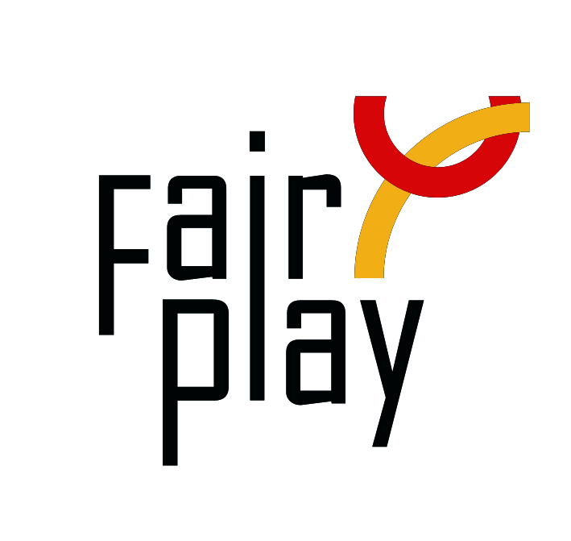SUBMISSION OF CANDIDACY

**QUESTIONNAIRE FOR C.I.F.P. AWARDS NOMINATIONS FOR THE YEAR 2020**

The C.I.F.P. awards distinctions for fair play under the following category each year:

**Pierre de Coubertin World Fair Play Trophy**

**to an athlete, or a team, for an ACT of fair play that cost, or could have cost**

**his/her victory, or could have downgraded his sport performance;**

|  |  |  |  |  |  |  |  |  |  |  |
| --- | --- | --- | --- | --- | --- | --- | --- | --- | --- | --- |
| 1. **Name, address of the person or organization proposed for the nomination:**   **Name (Ms./Mr./organization):**  **E-mail:**  **Profession or current occupation:**  **Date of the act:**  **Place of the act (city, country):**  **Name of the competition:**   1. **Description of the act (max.100 words)** 2. **Source:** 3. **Second source (preferably in English):** 4. **Connection with aspects of fair play** 5. **Impact of the gesture** | | | | | | | | | |  |
|  |  |  |  |  |  |  |  |  |  |  |

___________________________________________________________________

**Name, title/function and address of the person or organization submitting this nomination:**

Name:

E-mail:

Date: Signature

*Please attach all available supporting evidence (photos, press clippings, reports etc.) justifying this nomination as well as a PHOTO*

*_________________________________________________________________________________*

The CIFP awards are the following in the ascending order of merit:

**I. Letter of Congratulations,**

**II. Diploma of Honor,**

## III. World Fair Play Trophies

**Fully substantiated candidacies for 2020 World Fair Play Awards can be submitted by the 15th of February 2021 to the below address:**

***E-mail: nominations@fairplayinternational.org***

International Fair Play Committee

Attn. Dr Jenő KAMUTI – President

# H-1124 Budapest, Csörsz u. 49-51. Hungary